**Prepare hardware and software specification for basic computer system.**

The Hardware and Software Specifications for Basic Computing System

1. Processor (CPU): Intel Core i5 processor with a speed of 2.5 GHz.
2. Memory (RAM): 8 GB RAM capacity.
3. Storage: Includes a 256 GB SSD for fast storage and a 1 TB HDD for additional storage capacity.
4. Graphics: Integrated Intel HD Graphics.
5. Display: Features a 15.6-inch screen with a resolution of 1920x1080 pixels.
6. Connectivity: Supports Wi-Fi 802.11ac, Bluetooth version 4.2, and includes ports for USB 3.0, HDMI, and Ethernet connections.
7. Input Devices: Includes a full-size QWERTY keyboard and an optical USB mouse.
8. Audio: Built-in stereo speakers.
9. Operating System: Comes with Windows 10 Home pre-installed.
10. Internet Browser: Google Chrome is the default web browser.

**Identify networking cable standards. Create and test cross - over and straight cables.**

Networking cable standards include:

1. Ethernet:

* Category 5e (Cat5e): Commonly used for 1000BASE-T (Gigabit Ethernet) networks.
* Category 6 (Cat6): Supports higher data transfer speeds and is suitable for 10GBASE-T (10 Gigabit Ethernet) networks.

1. Fiber Optic:

* Single-mode fiber (SMF): Designed for long-distance communication, typically used in telecommunications.

To create and test crossover and straight cables, you’ll need:

* Ethernet cables (Cat5e, Cat6, etc.)
* RJ45 connectors
* Crimping tool
* Cable tester

**Creating a Straight Cable:**

1. Cut the cable to the desired length and strip about 1.5 inches of the outer jacket.
2. Untwist and arrange the color-coded wires in the correct order according to the T568A or T568B standard.
3. Trim the wires to the same length and insert them into the RJ45 connector.
4. Use the crimping tool to crimp the connector onto the cable.

**Creating a Crossover Cable:**

1. Follow the same steps as for a straight cable to prepare the cable and strip the wires.
2. Arrange the wires according to one standard on one end (e.g., T568A) and the other standard on the other end (e.g., T568B).
3. Trim and insert the wires into the RJ45 connectors on each end.
4. Crimp the connectors onto the cable.

**Configure the IP address of the computer.**

To configure the IP address of a computer, you can follow these general steps for Windows:

1. Open Network Settings: - Right-click on the network icon in the system tray and select “Open Network & Internet settings” or go to Control Panel > Network and Sharing Center.
2. Change Adapter Settings: - Click on “Change adapter options.”
3. Select Network Adapter: - Right-click on the network adapter you want to configure and select “Properties.”
4. Configure TCP/IP: - Double-click on “Internet Protocol Version 4 (TCP/IPv4)” or “Internet Protocol Version 6 (TCP/IPv6)” depending on your network setup.
5. Enter IP Address: - Choose “Use the following IP address.” Enter the IP address, subnet mask, default gateway, and DNS server addresses as required by your network administrator or setup.
6. Save Settings: - Click “OK” to save the settings.

**Create a basic network and share file and folders.**

To create a basic network and share files and folders, you can follow these general steps:

1. Connect Computers to the Same Network:
   * Ensure that all computers you want to connect are on the same network, either wired (using Ethernet cables) or wireless (using Wi-Fi).
2. Enable File and Printer Sharing:
   * Go to Control Panel > Network and Sharing Center.
   * Click on “Change advanced sharing settings” on the left.
   * Turn on “Network discovery” and “File and printer sharing” for the appropriate network profile (e.g., Private).
3. Share a Folder:
   * Right-click on the folder you want to share and select “Properties.”
   * Go to the “Sharing” tab.
   * Click “Advanced Sharing.”
   * Check “Share this folder.”
   * Click “Permissions” to set access permissions.
4. Access Shared Folder:
   * Open File Explorer and go to Network.
   * You should see the other computers on the network. Double-click to access shared folders.

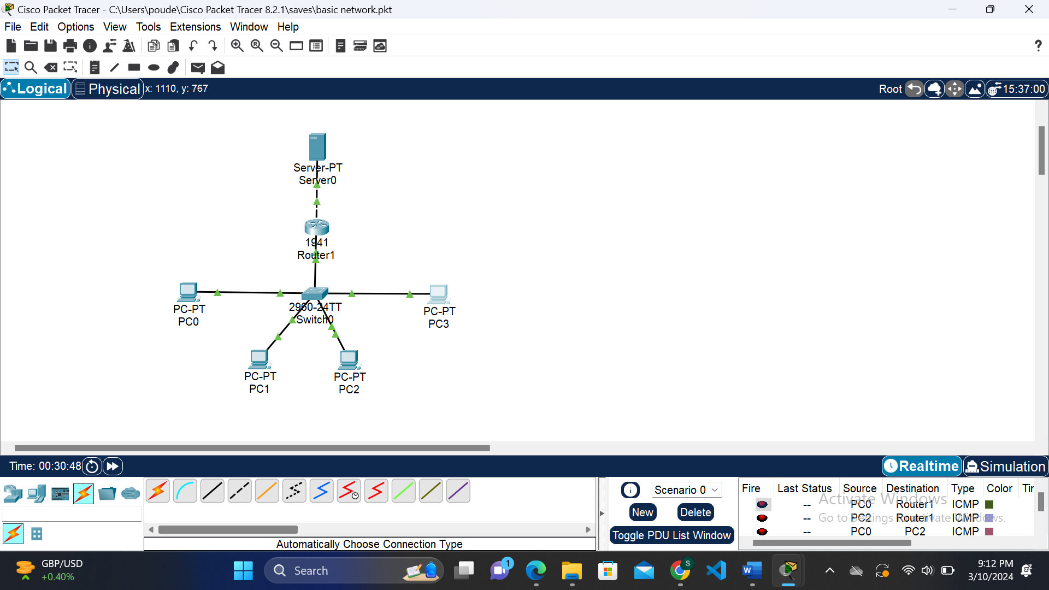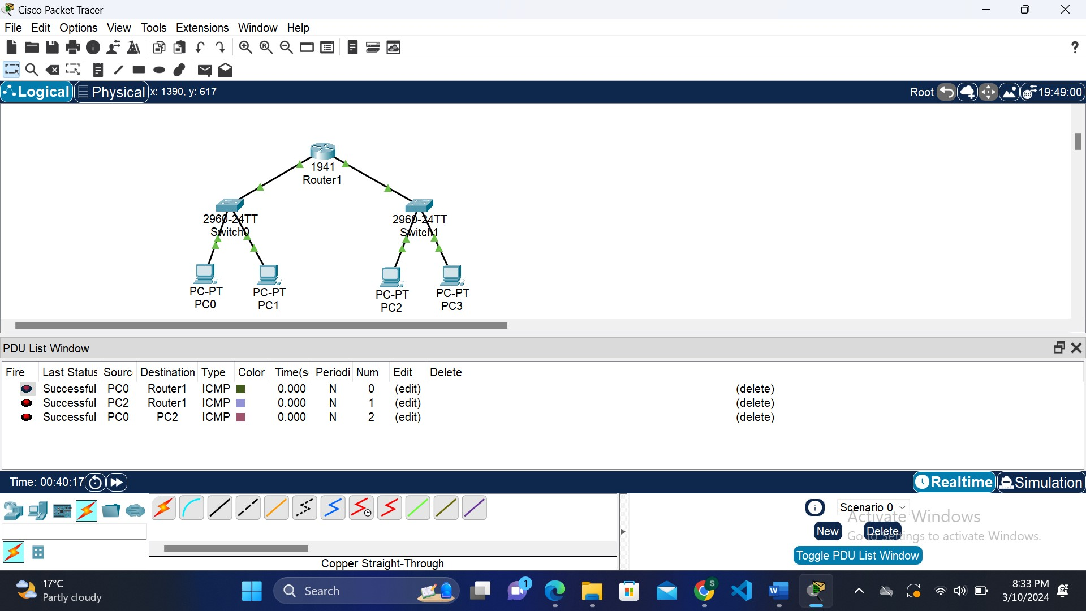

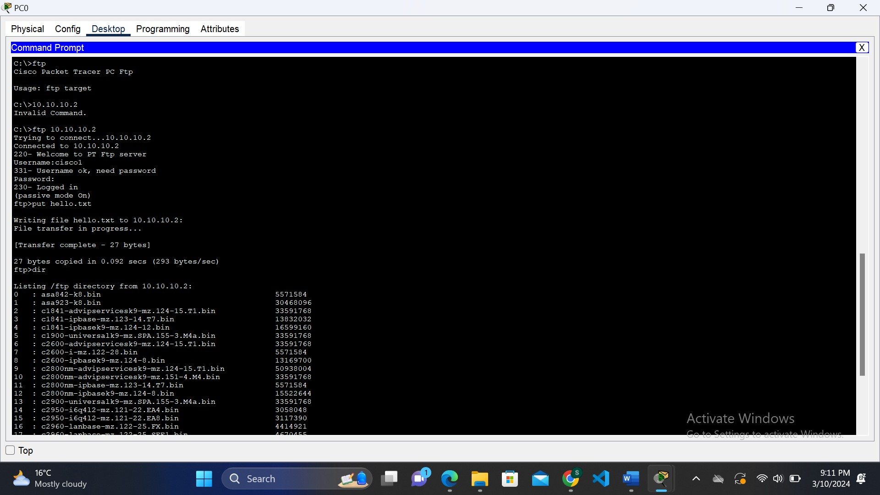

**Install packet tracer and identify the features of packet tracer.**

For installing Cisco Packet Tracer:

* Create a Cisco Networking Academy account on their website.
* Enroll in the Packet Tracer Course if necessary.
* Download the appropriate version for your OS from the Packet Tracer download page.
* Install the software following on-screen instructions (may require administrative privileges).
* Launch Packet Tracer after installation.
* Log in with your Cisco Networking Academy credentials.
* Begin creating and simulating networks with Packet Tracer.

The features of packet tracer are:

-**Network Simulation:**

Packet Tracer simulates network behavior, allowing users to design, configure, and troubleshoot networks in a virtual environment.

**-Wide Range of Networking Devices:**

The tool supports a variety of Cisco networking devices, including routers, switches, hubs, wireless devices, and more.

**-Packet-Level Simulation:**

Users can view and analyze packets at a detailed level, helping to understand how data flows through a network.

-**Real-Time Mode and Simulation Mode:**

Users can switch between real-time mode and simulation mode to observe real-time network behavior or pause and analyze network states.

-**User-Friendly Interface:**

Packet Tracer has an intuitive and user-friendly interface, making it accessible for users at various skill levels.

**Implement the LAN topologies.**

Creating different types of LAN topology.

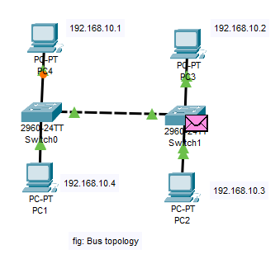

Fig: Bus Topology

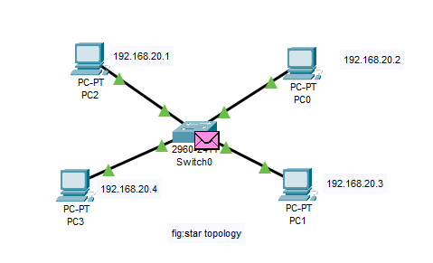

Fig: Star Topology

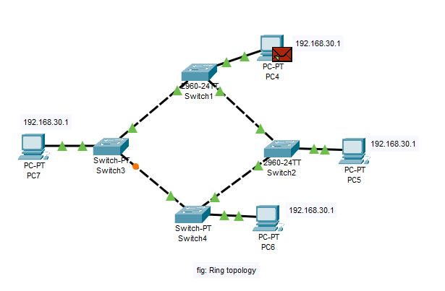

Fig: Ring Topology

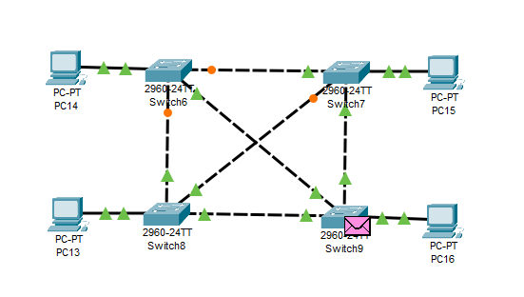

Fig: Mesh Topology

**Demonstrate the use of VLAN.**

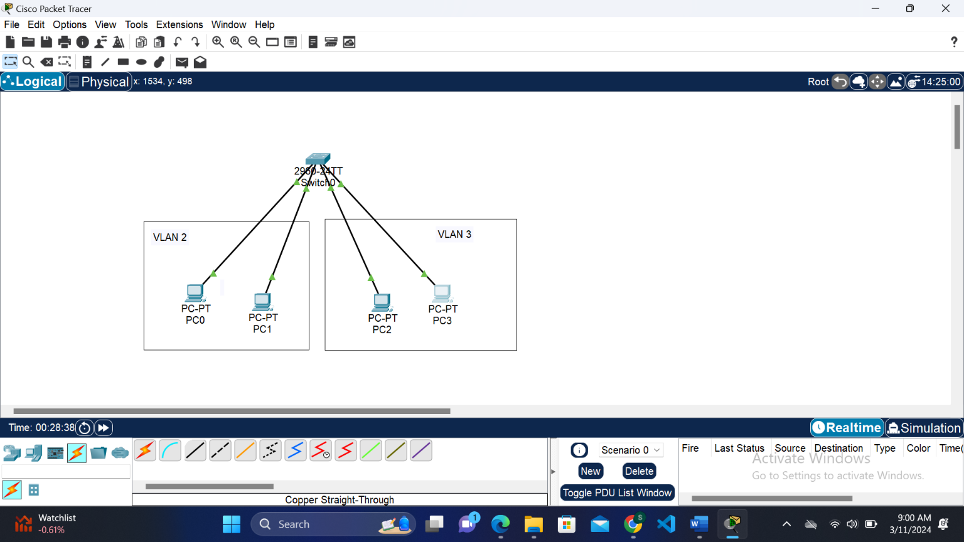

Implementation of VLAN network.

Creating and configure VLAN

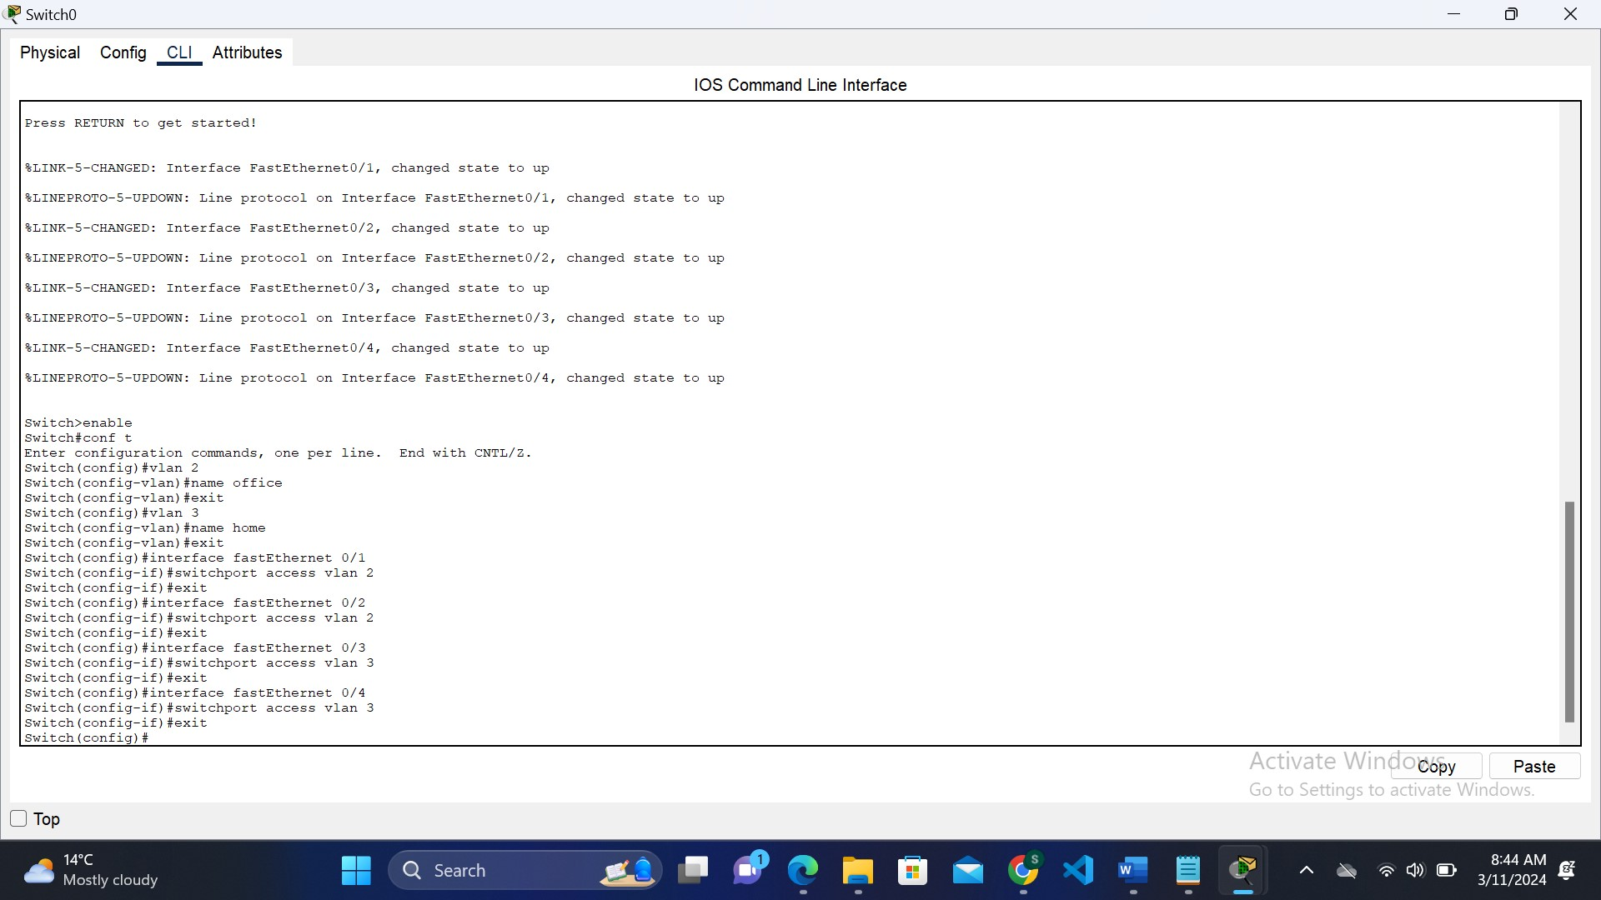

**Implement the both static and dynamic router configurations.**

Static routing

* Configuration of static routing

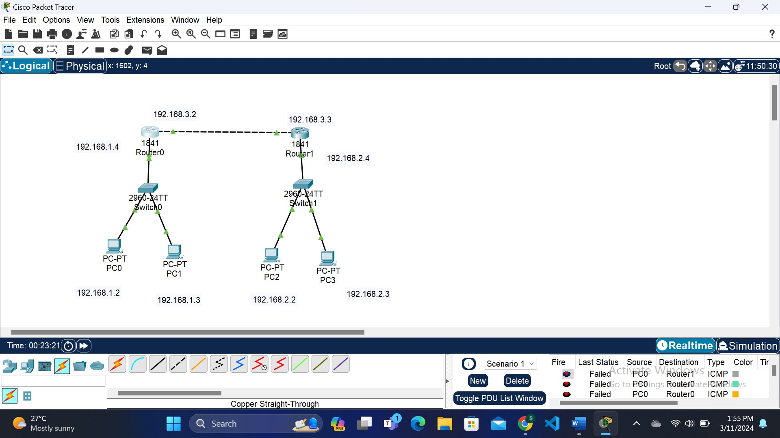

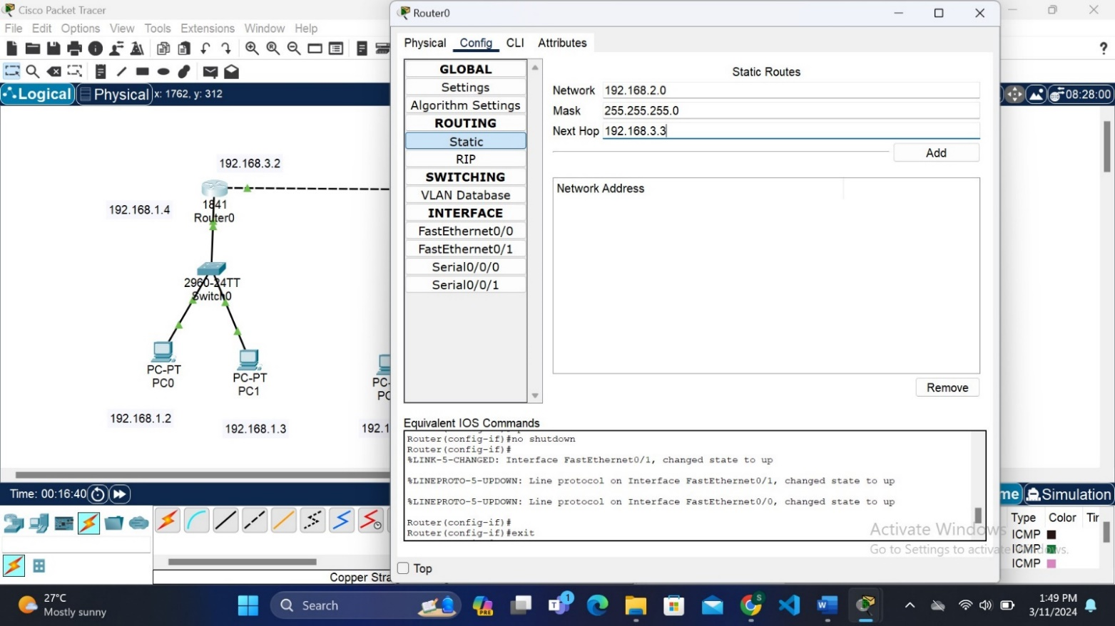

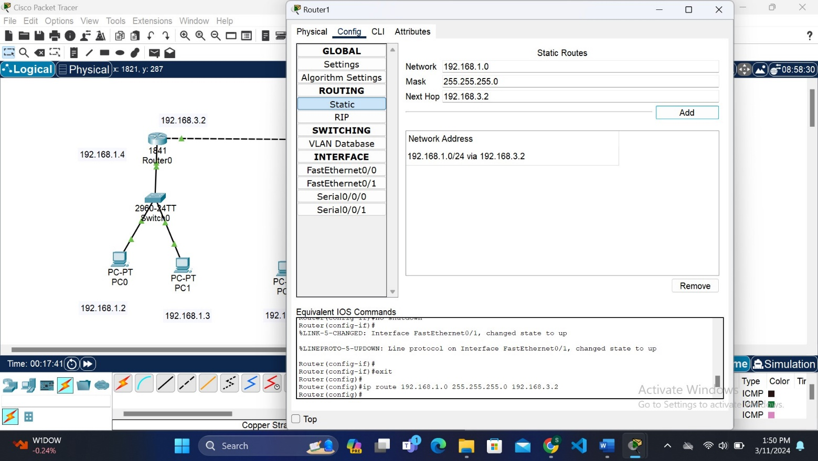

Dynamic routing:

* configuration of dynamic routing

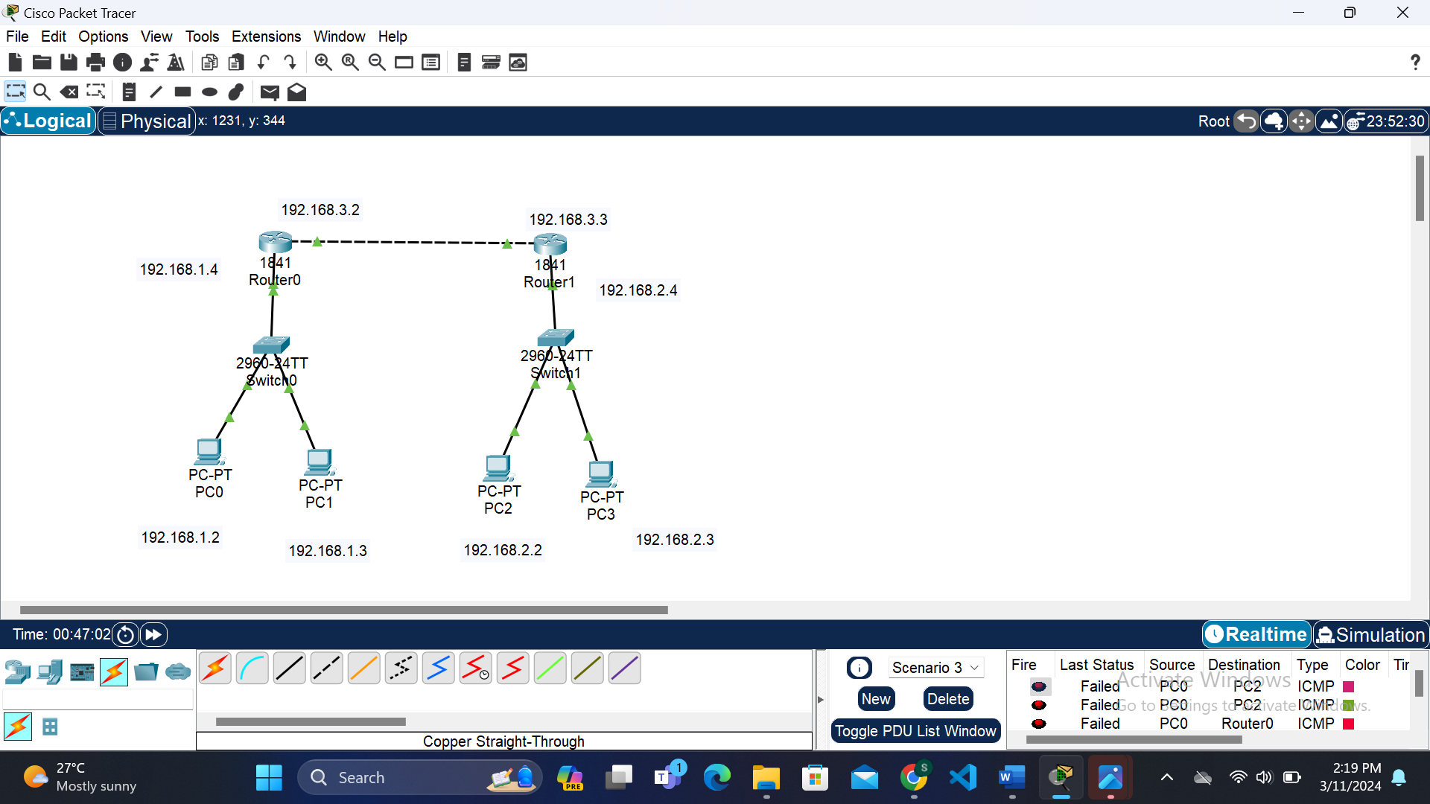

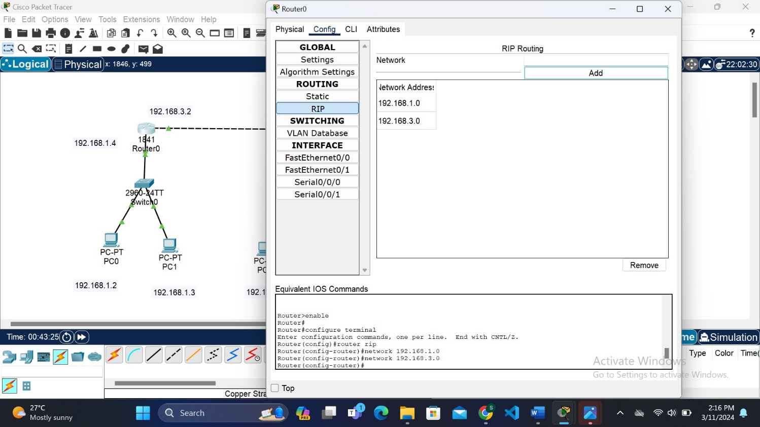

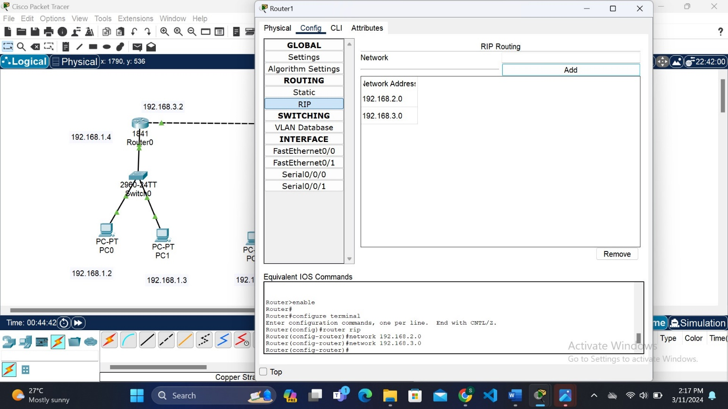

**Implementation of firewall.**

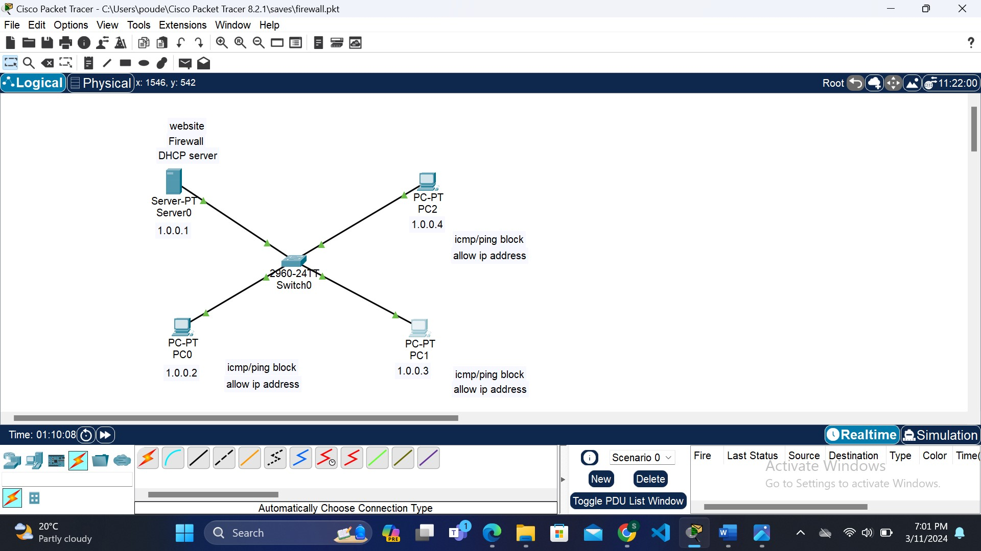

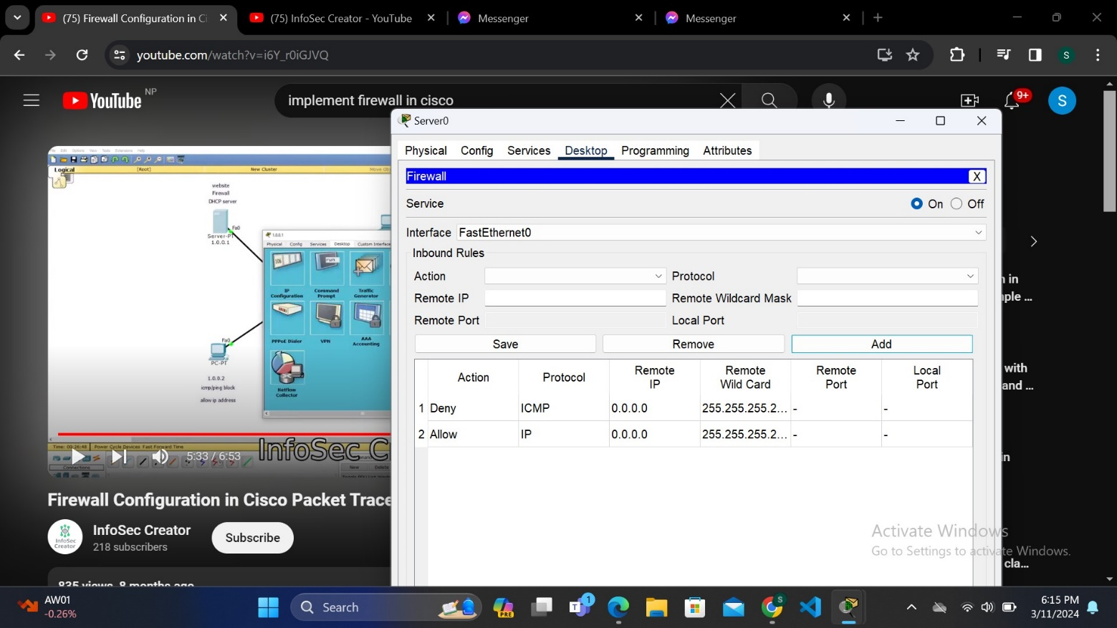

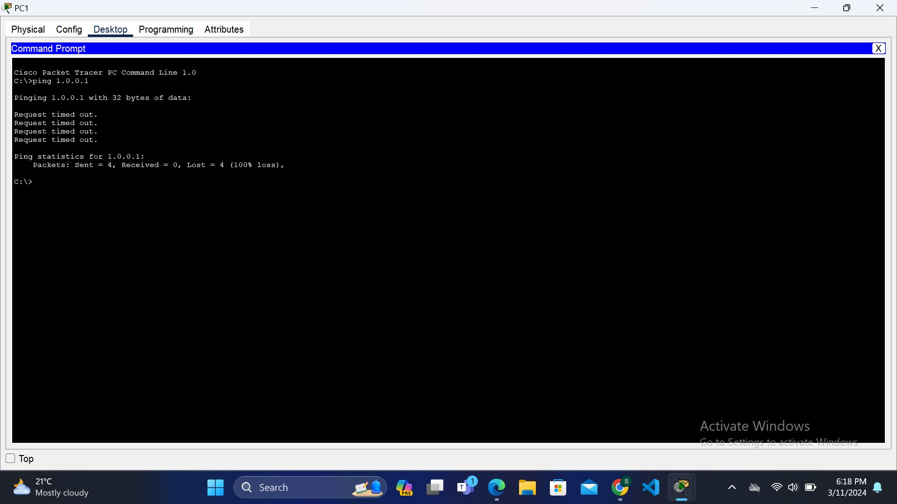

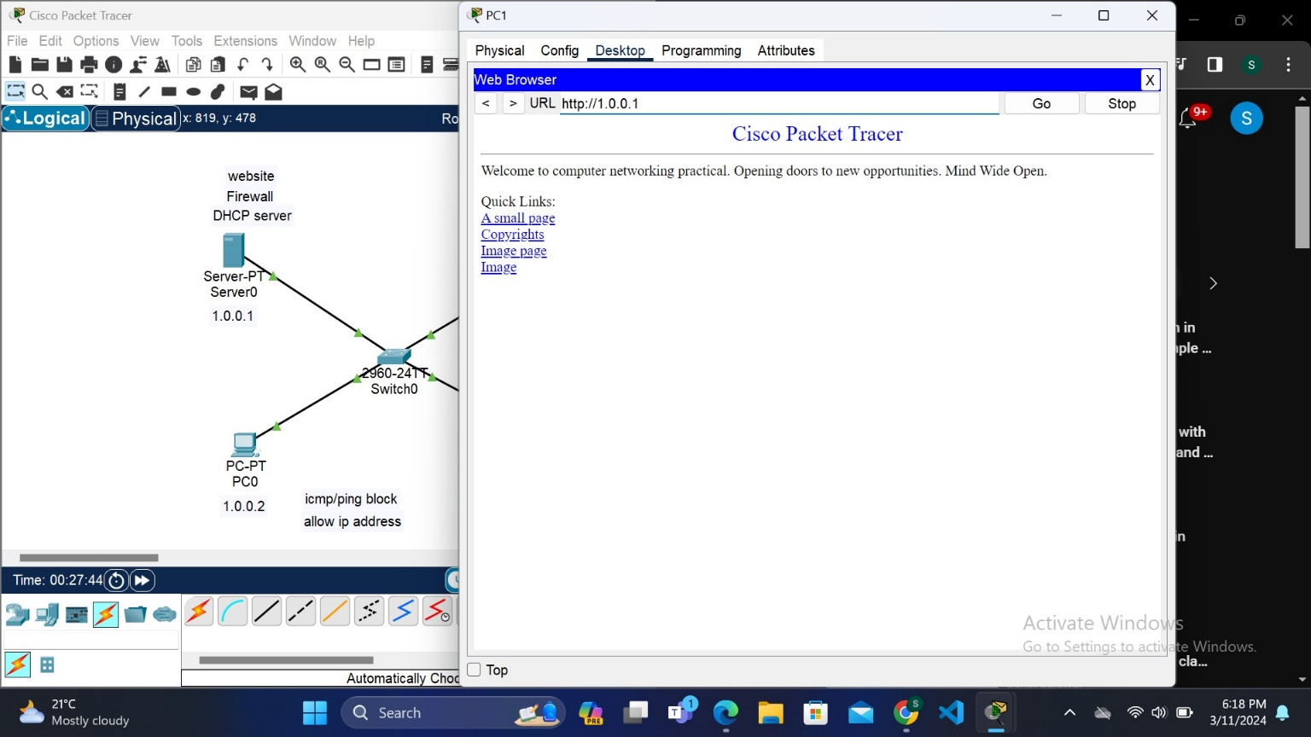

**Capture some packets and analyze the header using Wireshark.**\

